Name: Jamie Anthony Brindle
Student ID: 06352322
Title: Website Development: Online Bookshop Assignment 1 Demonstration and Testing
Users Area, User Privileges

User Login:
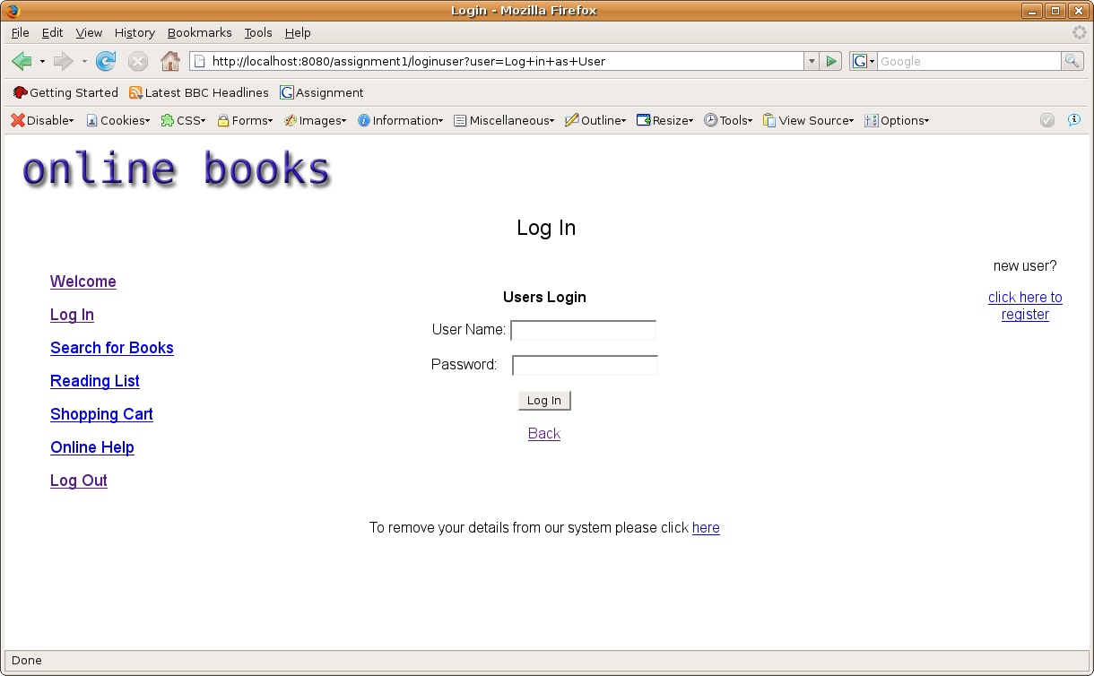
user are able to log in from here, or if they wish remove their user accounts

Users Login: Users removing their own user accounts
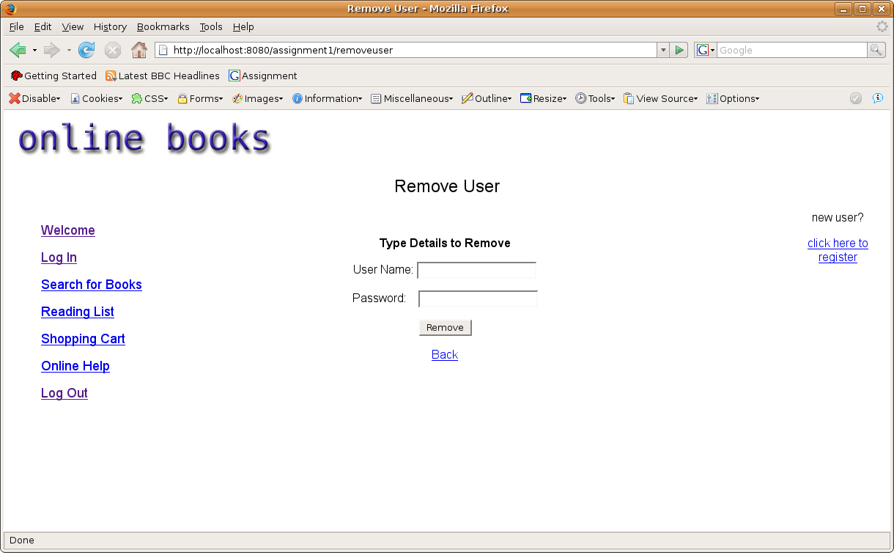
users can remove their accounts only if they known their user name and password

Remove User: Confirmation (unsuccessful)
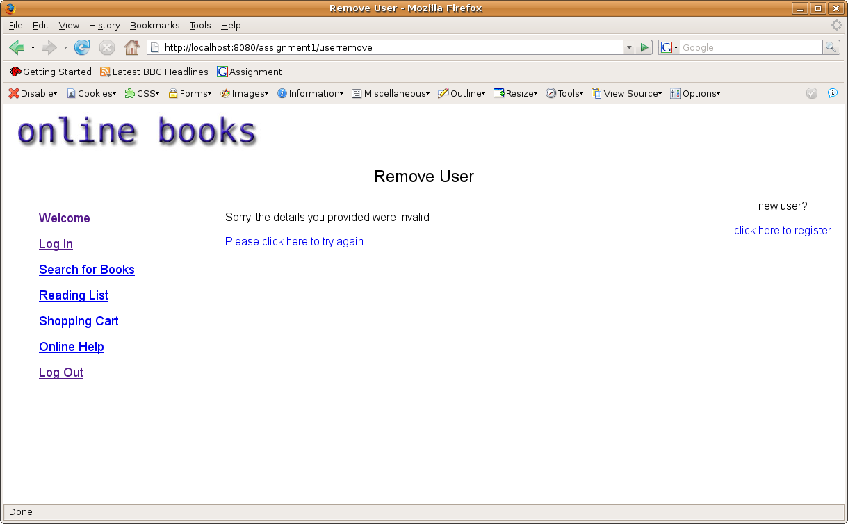
Error message appears asking the user to try again if details don't match those on database

Remove User: Confirmation (successful)
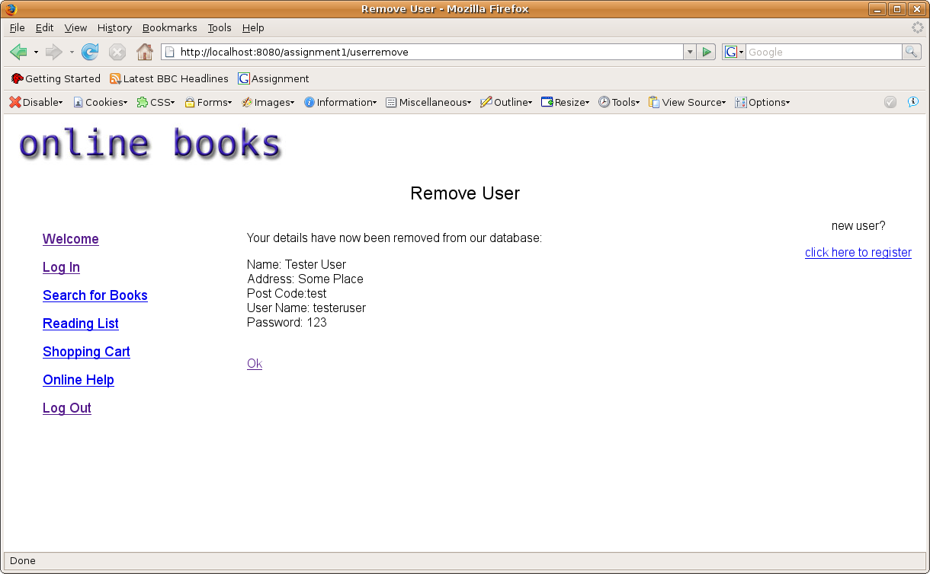
Confirmation of successful removal

Login User: Users unsuccessfully logged in
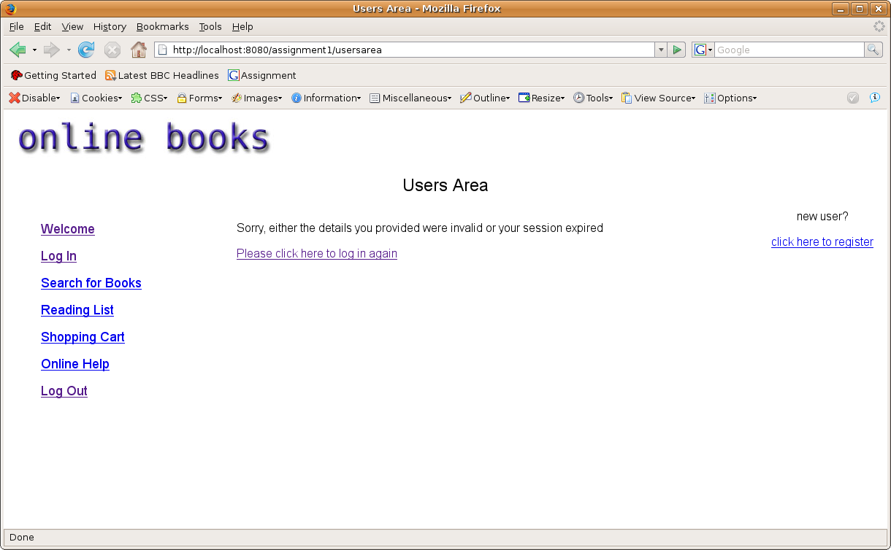
Error message appears asking the user to try again

Login User: User logged in successfully
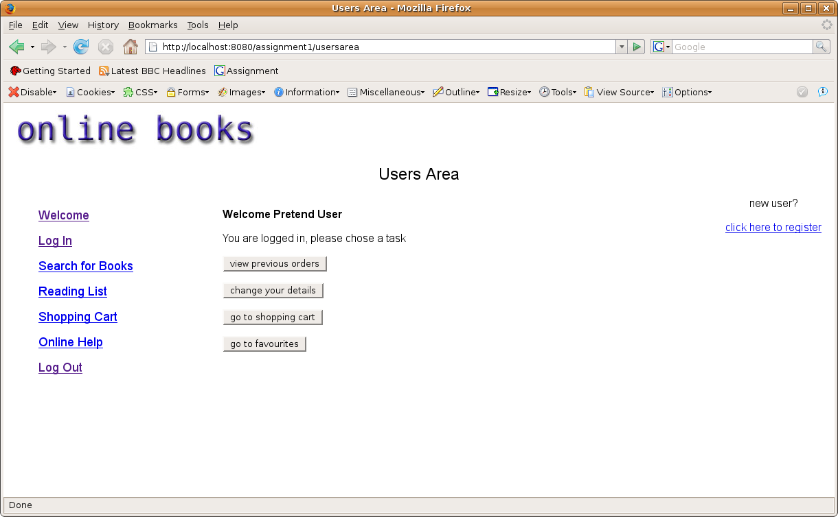
Menu appears, greeting the user by name and session cookies are stored, storing user name, user password and a validation cookie so users may revisit this menu again without having to log in. Menu includes viewing previous orders (which we have already covered), changing user details (which we will cover next), going to shopping cart (which we have already covered) and going to favourites (which we have already covered)
User Area: Changing user details
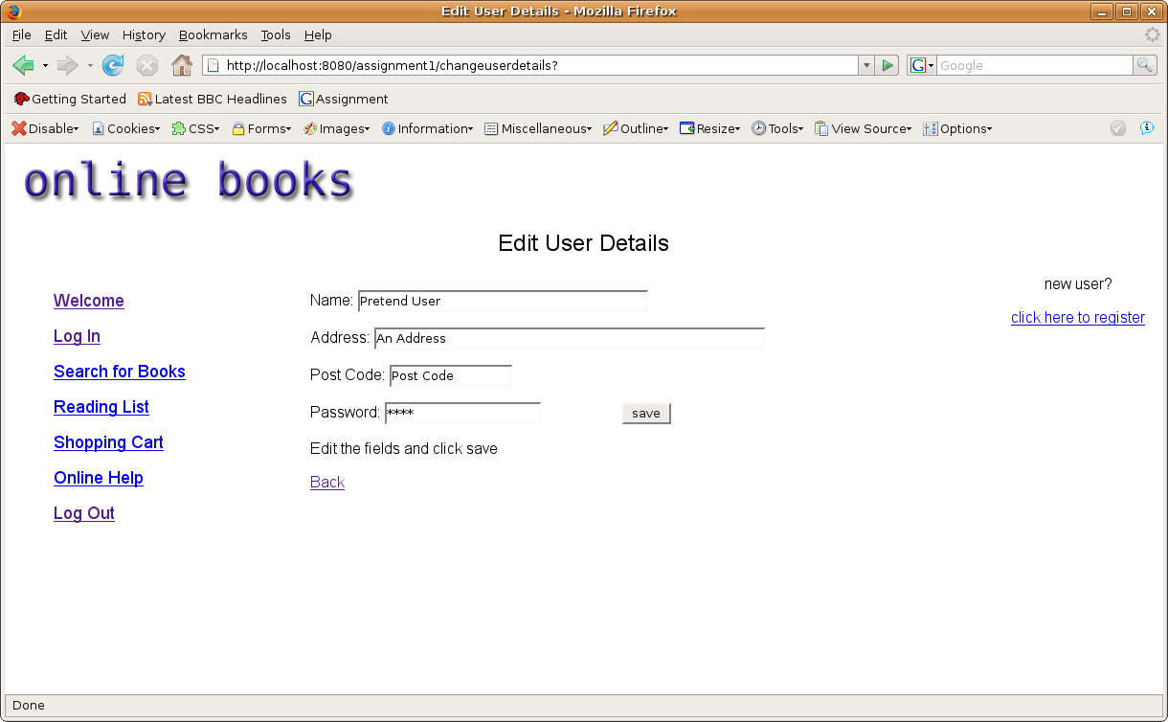
Editable text fields appear that allow users to change all details but their unique user name, and save

Edit User Details: Confirmation of successful change in details
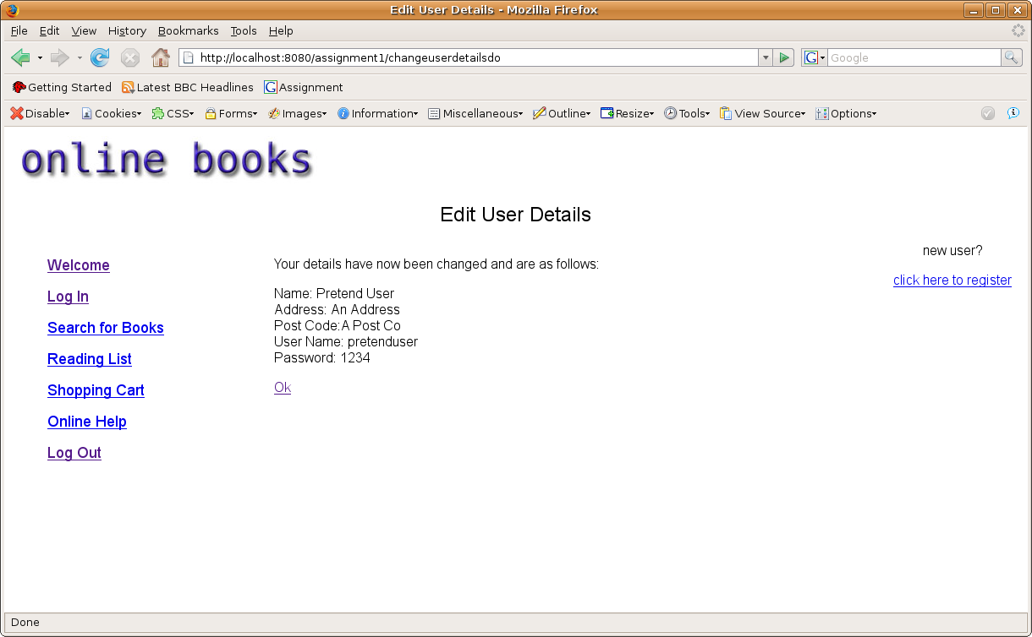
Confirmation appears showing new user details and updating database

Edit User Details: Double Check details have successfully changed
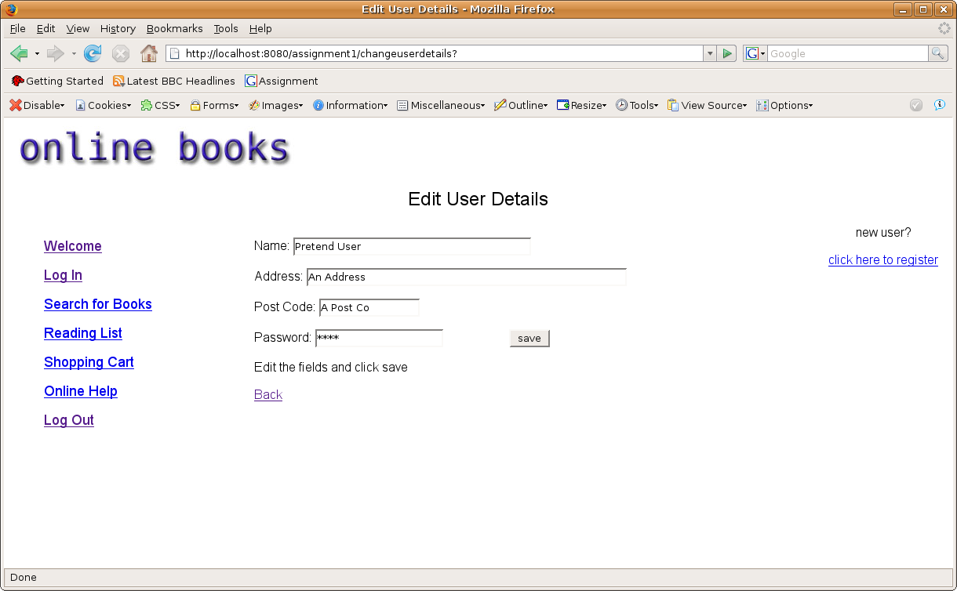
Details successfully changed as expected

